## Merchant Name: **WEVO** Implementation POC: Royce *(IM to fill)* CX POC: *[IMP to Add]*

### 

| Notes Sections   *(AE to fill if they have, Implementation to be completion DRI on handoff)*   * Info on how merchant bills   SaaS billing with two primary products. May introduce new products in the future.  1) What is the merchant temperament?  Annie is a talker, exuberant, competent and great to work with. She has expressed being excited to work with us on solving her challenges  3) What are the Tabs features that the key POC cares about?  Current - automated contract management, collaboration and efficiency features (slack/Hubspot integrations), pushing data for ARR and Bookings to Mosaic via export  Future - migrating their PLG billing to Stripe so that they can take advantage of Tabs’ SLG/PLG reporting. They may also migrate from Mosaic to Runway in ~October  Goals:   * Increase efficiency and bring more organization to her team's work, as she cannot continue at the current pace * Find a solution that can serve as a single source of truth for contracts, as the current disorganized storage in Google Drive is very time-consuming * Explore using the solution as a central customer management tool, where her team and the new Customer Success Manager can easily access information about customers using things like the slack and hubspot integrations * Automate as much of the collections process as possible to reduce reliance on the outsourced accounting team/save money * Ensure a seamless billing process and maintain the current Annual Recurring Revenue (ARR) tracking in Mosaic (Vanessa scoped and we will coordinate support during IM) |
| --- |

### Billing model *(Entire Section: Implementation to fill section)*

* Are there unique things about the customer creation process for this merchant?
* Information on how merchant bills
* How contract is broken up
* One off things to know about the merchant

### Contract Processing Steps *(Entire Section: Implementation/Success to fill Post-Go Live)*

1. Steps to process

Integration Item: [ ]

Billing Timing: Bill First of Period

* **General**
  + Process one billing term per contract term (typically annual) unless the contract explicitly splits invoicing
* **Item name**
  + Use “SaaS Services and Professional Services” unless a more specific descriptor is given for the Insight or Journey product
    - Ex. “WEVO Insight” or “WEVO Pulse”
* **Quantity**
  + Use the number of included credits if listed
  + Default to 1
* **Total price**
  + Use the total contract price for the included credits. Do not divide per credit unless the contract explicitly breaks out invoicing.
* **Frequency** 
  + Set based on the billing cadence in the contract
* **Service start date**
  + Use the contract’s effective date
* **Billing start date**
  + Match the service date unless another billing/invoice timing is specified
* **Months of service**
  + Calculate based on start and end dates
    - Default 12 months
* **Net terms**
  + Use stated payment terms
    - Default 30 days
* **Billing type**
  + FLAT
  + Even though the pricing model is labeled as “usage” these are typically prepaid packages of credits. Process accordingly.
  + Examples:
    - 24 credits for $72,000 (FLAT)

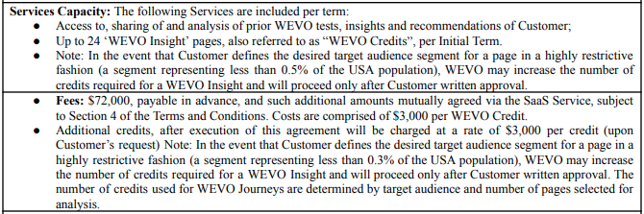

* + - 16 credits for $55,000 → Flat BT titled "WEVO Insight(s)"
    - 16 additional credits at $3,400 each → separate usage BT titled "Additional WEVO Insight credit"

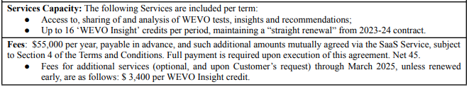

* + - $375/month for 15 WEVO GAIS credits → Flat BT titled "GAIS Fees"
    - Quantity = 15, Frequency = Monthly, Total Price = $375/month

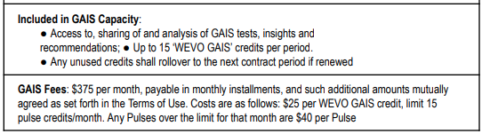

* **Special cases**
  + Wawa: This [contract](https://garage.tabsplatform.com/prod/contracts/d7b304d7-fa9d-4933-b77b-327ea16e15b2/terms/key) includes both a flat BT and a usage BT for additional credits:
    - Flat BT should follow standard rules for prepaid Insight credits.
    - Usage BT should be mapped as monthly in arrears with unit pricing per credit (event type: Credits).

### Events Processing (if necessary) *(Entire Section: Implementation/Success to fill Post-Go Live)*

* Any important information on events billing

Integration Items Processing (if necessary)  
*(Entire Section: Implementation/Success to fill Post-Go Live)*

* What are the instructions for assigning integration items?
* Example: All Statsig integrations items should be labeled as “Sales”
* Example: All “Pinata” integration items should be labeled as “Software Subscription Bundle” unless otherwise noted by Merchant

Post Processing Communications (if necessary)  
*(Entire Section: Implementation/Success to fill Post-Go Live)*

* Does the Ops Team need to notify anyone on the team re: completion of processing batches in Implementation or Active phase?
* Who needs to be notified and when?
  + Example:
    - Who: Customer Success [Azmat Aziz] needs to be notified
    - Where: Messari internal merchant channel
    - When: contracts are processed [Merchant Phase: Active]

### Customer Information *(Entire Section: Implementation/Success to fill Post-Go Live)*

* Any important information on specifics customers of this merchant
  + Special memo’s certain invoices require
  + Invoice changes due to merchant/customer relationship

### Feature Requests *(AE to fill for all requests prior to Imp handoff, Imp to fill prior to go-live/Success to fill to fill Post-Go Live)*

* FR 1
  + What is it
  + Why it's important
  + Urgency

### Merchant Calls *(AE to fill for all videos prior to Imp involvement, Imp to fill prior to go-live/Success to fill to fill Post-Go Live)*

* Annie / Ben Catch up (first call since late last year <https://us-56595.app.gong.io/call?id=6731822181222776398>
* Demo <https://us-56595.app.gong.io/call?id=6748069873295800785>
* PLG/SLG discussion with Annie and Tabs Jon <https://us-56595.app.gong.io/call?id=2175070243838742757>
* Ben and Annie discuss integrations - <https://us-56595.app.gong.io/call?id=3366202905538628361>
* Jon, Annie and Ben discuss PLG/SLG motion again - <https://us-56595.app.gong.io/call?id=5258727310429478367>
* Ben and Vanessa scope needs for Mosaic - <https://us-56595.app.gong.io/call?id=3403361204937952617>
* Verbal for Signature and Annie confirming which reports she cares about in Mosaic (4 min convo) - <https://us-56595.app.gong.io/call?id=8136923179866104842>